|  |  |
| --- | --- |
| Power BI Lab Day 1 Document | |
|  |  | | |
| **Writer:** | I&D Microsoft | | **Initials entity:** |
| **Date creation:** 24/04/2018 | |  | **Last upgrade:** 25/04/2018 |

Power BI LAB DOCUMENT

DAY 1- Lab 1

|  |  |  |  |  |
| --- | --- | --- | --- | --- |
| Version | Author | Comment | Reviewed By | Date |
| V 1.0 | I&D Microsoft | Initial draft | Moupiya Das |  |
|  |  |  |  |  |
|  |  |  |  |  |

**Pre-requisites**

Installed and working Power BI Desktop setup.

**Environment Setup**

1. **Installing Power BI Desktop**

Power BI Desktop lets you create a collection of queries, data connections, and reports that can easily be shared with others. Power BI Desktop integrates proven Microsoft technologies – the powerful Query engine, data modeling, and visualizations – and works seamlessly with the online Power BI service. You will need to download and install Power BI desktop to perform the labs in this course.

* 1. **Which version to install?**

• If you have a 32 bit machine, you need to install the 32bit Power BI Desktop.

• If you have a 32 bit Office installed (regardless of your machine), you need to install the 32 bit Power BI Desktop.

• Otherwise, you can install the 64 bit PBI Desktop.

**1.2 Minimum requirements**

• Windows 7 / Windows Server 2008 R2, or later

• .NET 4.5

• Internet Explorer 9 or later

**1.3 Download and install Power BI Desktop**

You can download and install the latest version of Power BI Desktop in two ways,

1. Directly from Microsoft link, http://go.microsoft.com/fwlink/?LinkID=521662

**Note: To select which version to download, go to** [https://www.microsoft.com/en-us/download/details.aspx?id=45331](https://www.microsoft.com/en-us/download/details.aspx?id=45331%20) and select appropriate version.

2. Or, from Power BI Service site, <https://app.powerbi.com/>, i.e., in Power BI, click the Downloads > **Power BI Desktop**.



1. **Signing Up for Power BI Service**
2. Browse to [powerbi.com](https://powerbi.microsoft.com/).
3. Select **Start Free** or **Sign up free**.

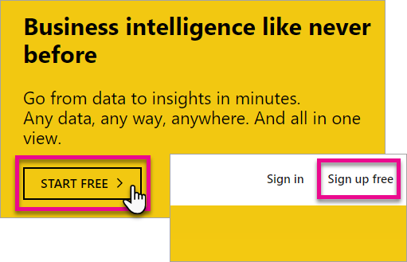

1. On the get started page, select **Try Free >** under Power BI.

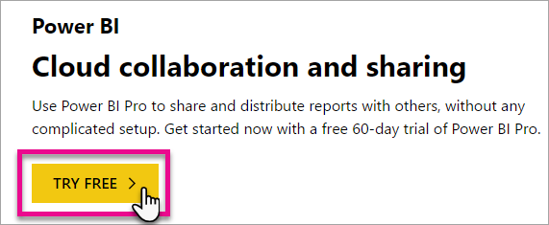

1. Enter the email address you are signing up with, and then select **Sign up**. Be sure your email address is allowed for sign up. For more information about what email address you can use, see [What email address can be used with Power BI.](https://docs.microsoft.com/en-us/power-bi/service-self-service-signup-for-power-bi#what-email-address-can-be-used-with-power-bi)



1. You will get a message indicating to check your email.



1. Select the link within the email to verify your email address. This will bring you back into the sign up flow. You may need to supply some additional information about yourself.
2. You will then be taken to [https://app.powerbi.com](https://app.powerbi.com/) and you can begin using Power BI as a free user.

**Lab Overview**

This lab comprises of three tasks:

1. In the first task, you will import data to Power BI Desktop from a web URL.

2. In the second task, you will edit the queries and transform the data accordingly.

3. In the third task, you will use visualizations to showcase the data and get simplified results.

**Case Scenario**

The web url from IMDb <https://www.imdb.com/chart/top?sort=ir,desc&mode=simple&page=1> provides the Top 250 movies based on IMDb Rating, Release Date and Rank. We need to create a simple report using Power BI making use of the basic transformations and visuals to get the idea of basic Power BI functionalities.

# Table of Contents

Table of Contents 7

1. Import Data 8
2. Edit Query ……………………………………………………………………………………………………………………………………….…….10
3. Transform Data…………………………………………………………………………………………….…………………………..…………..11
4. Data Visualization…………………………………………………………………………………………………………………………..……..18

# 1. Import Data

1. Start with a blank Power BI Desktop file.
2. Click on Get Data option in the ‘**Home**’ tab.

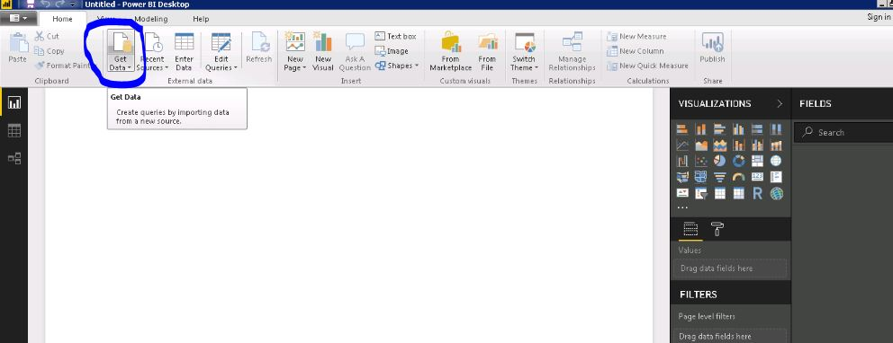

1. In the search option, type ‘**Web**’ and select web and click Connect.

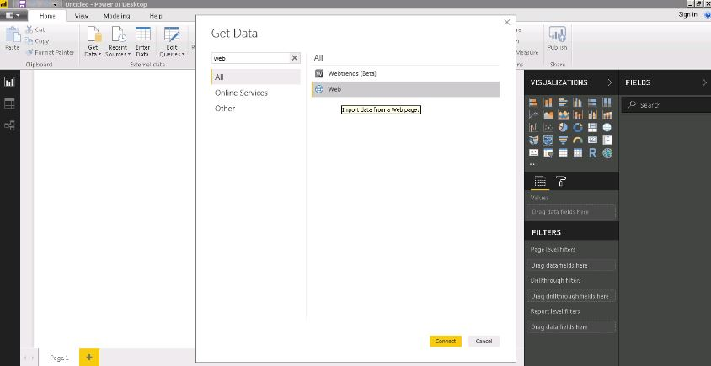

1. In the Url textbox, paste <https://www.imdb.com/chart/top?sort=ir,desc&mode=simple&page=1> and click OK.

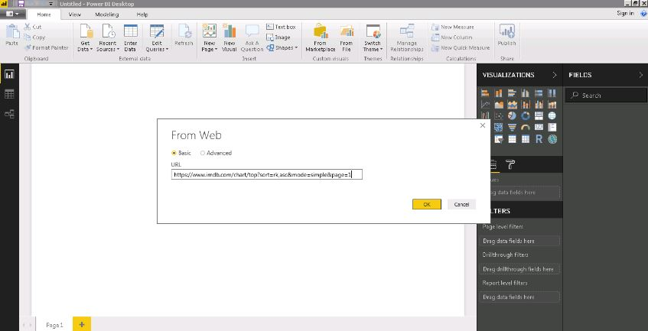

1. From the navigator pane, select ‘**Table 0**’ and click **Edit**.

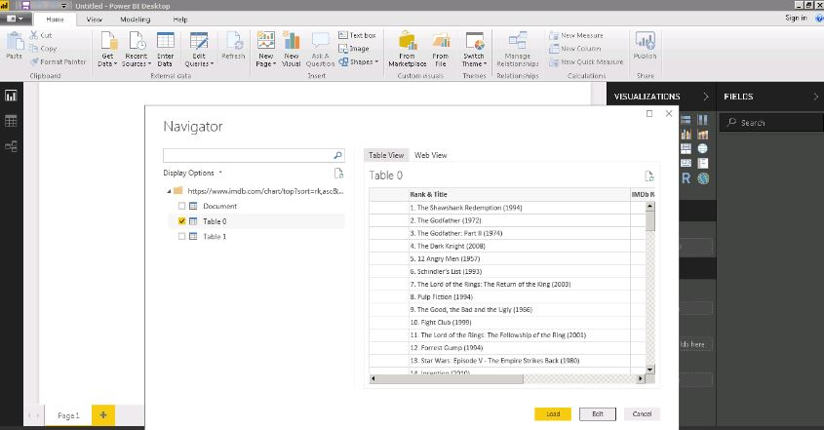

Clicking on ‘**Edit**’ would open the Query Editor for the Power BI file you’re creating. Below is the screenshot of how it should look.

# 2. Edit Query

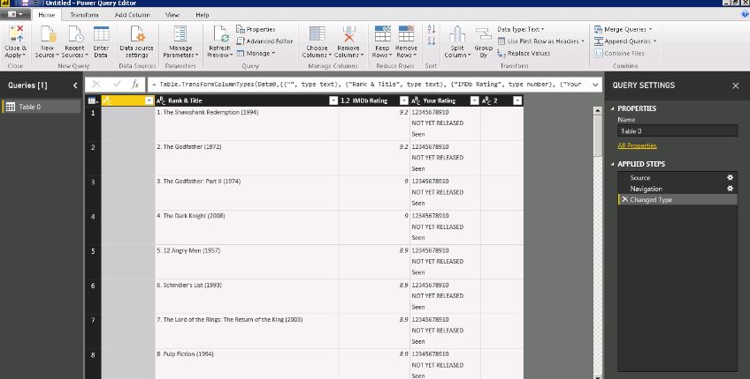

1. Right click on the first column and choose ‘**Remove**’ from the options.

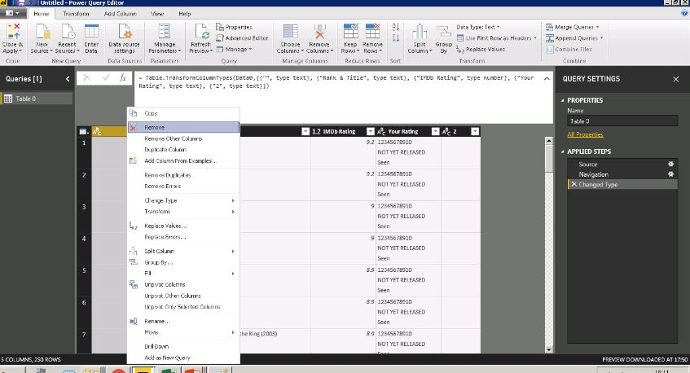

1. Similarly, for the last two columns i.e ‘**2**’ and ‘**Your Ranking**’, right click and choose ‘**Remove**’.

# 3. Transform Data

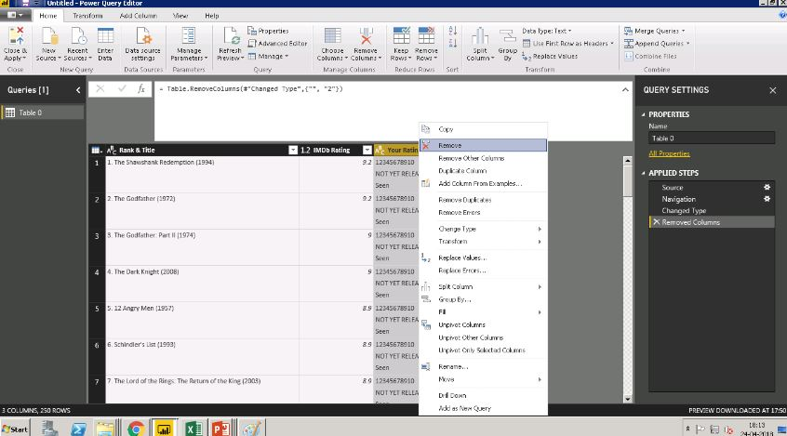

This would leave us with two columns i.e ‘**Rank & Title**’ and ‘**IMDb Rating**’.

1. Right click on the ‘**Rank & Title**’ column and select split column By Delimiter from the options.

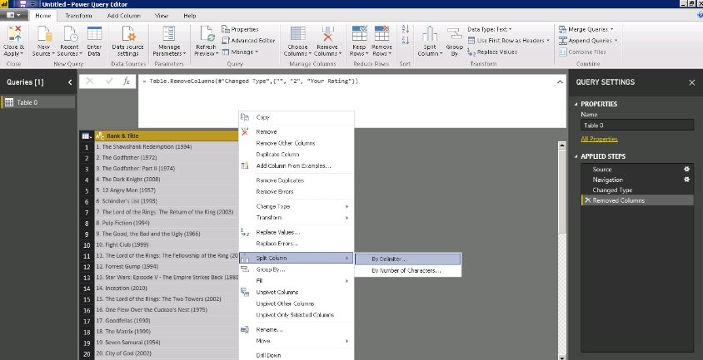

1. Select delimiter as ‘**.**’ and choose ‘**at left most delimiter**’ and hit **OK.**

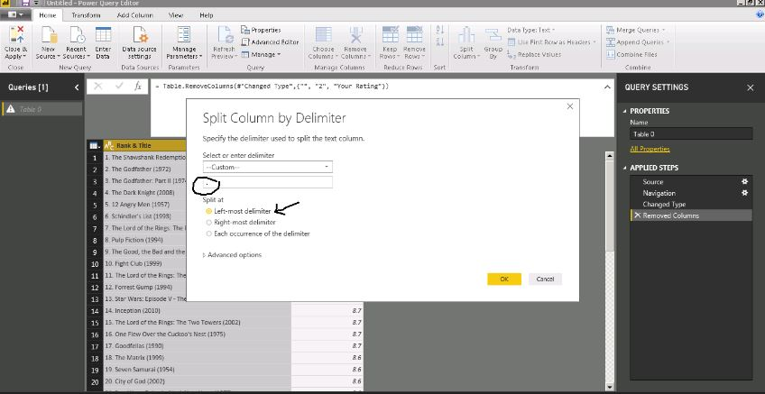

This would split the column separating Rank from the ‘**Rank & Title**’ column.

1. Right click on ‘**Rank & Title**’ and select split column by delimiter. Choose ‘**(**’ as the delimiter and split at ‘**at every occurrence of the delimiter**’.

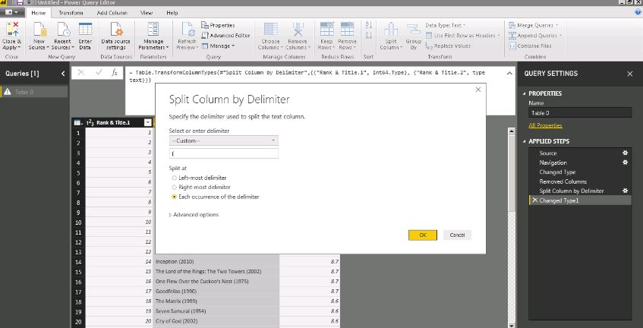

Your screen should look something like this.

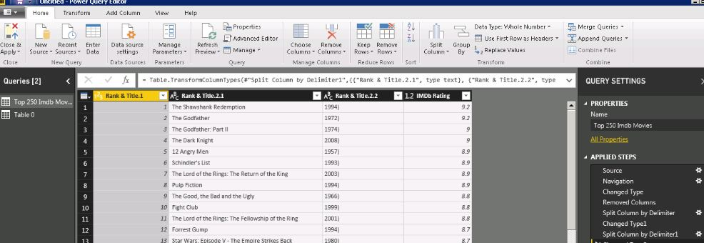

1. Again, split the new column ‘**Rank & Title.2.2**’ created choosing ‘**)**’ as the delimiter and splitting at ‘**at every occurrence of the delimiter**’.

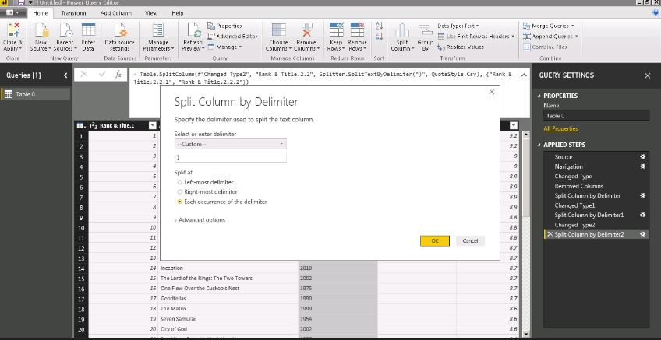

1. Right click on the column ‘**Rank & Title.2.2.2**’ and choose ‘**Remove’**.

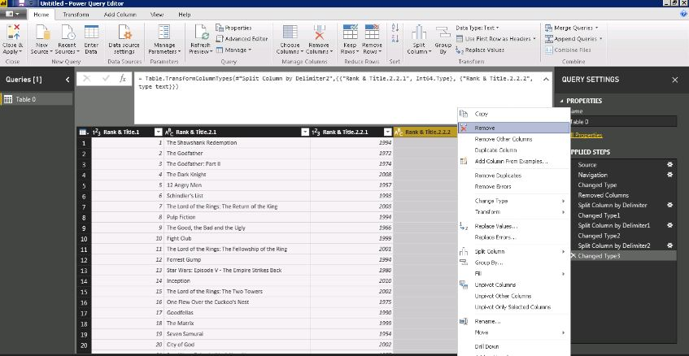

1. Right click on the first column ‘**Rank & Title.1**’ and select ‘**Rename**’. Rename it as ‘**Rank**’.

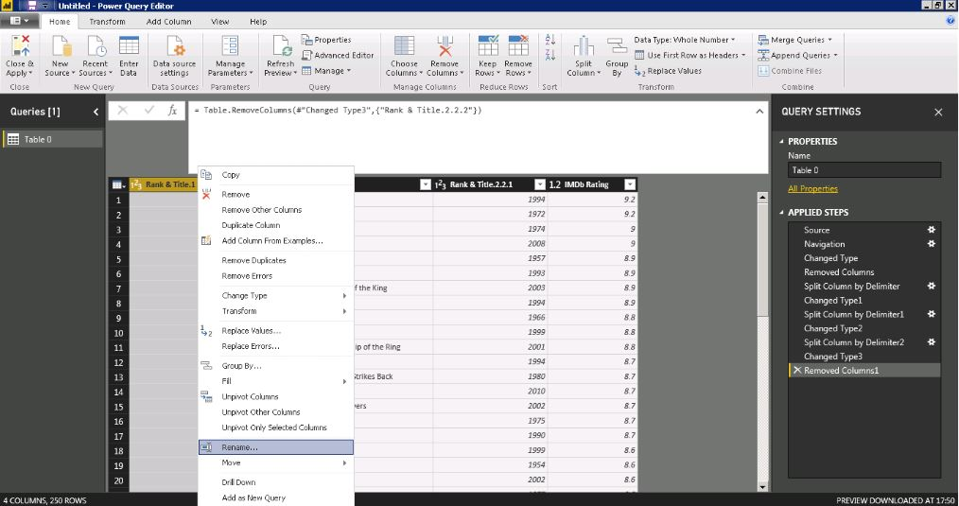

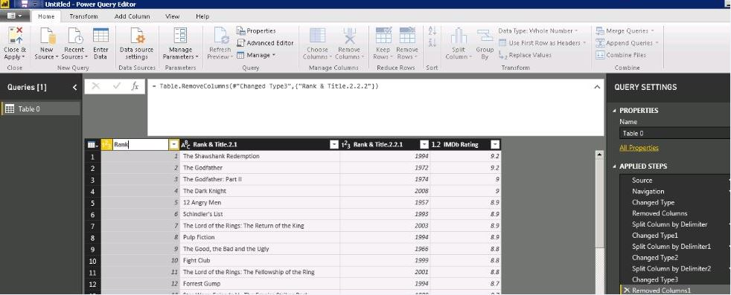

1. Similarly for columns ‘**Rank & Title.2.1**’ and ‘**Rank & Title.2.2.1**’ rename as “**Title**” and “**Year**” respectively.

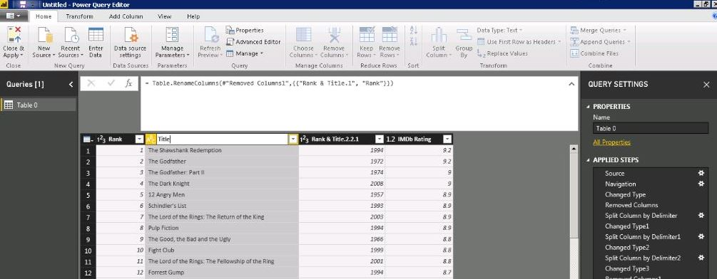

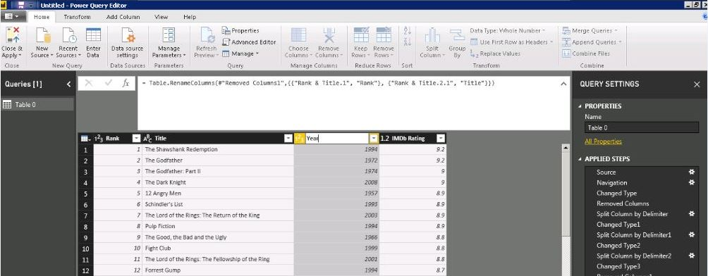

1. In the Properties, from the Query Settings Pane, Rename ‘**Table 0**’ to ‘**Top 250 Imdb Movies**’.

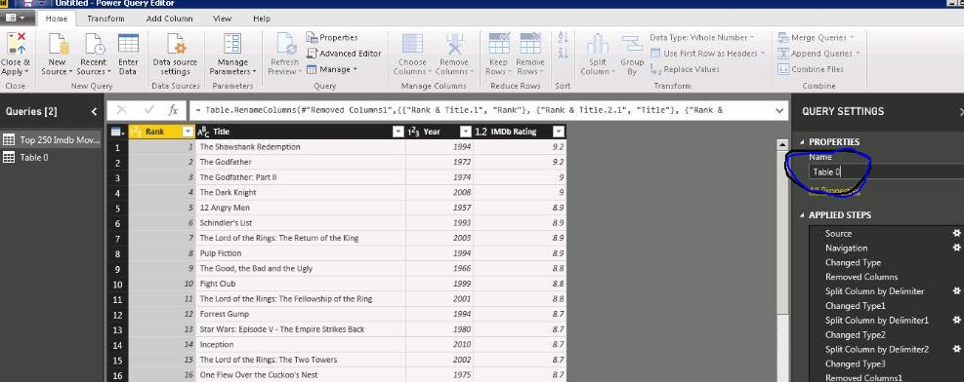

You can also rename the ‘**Applied Steps’** from the Query Settings pane for better understanding and further reference purposes.

1. Right click on the step you need to rename. In our scenario, we choose the first ‘**Split column by Delimiter’** to rename as ‘**Rank Split’**.

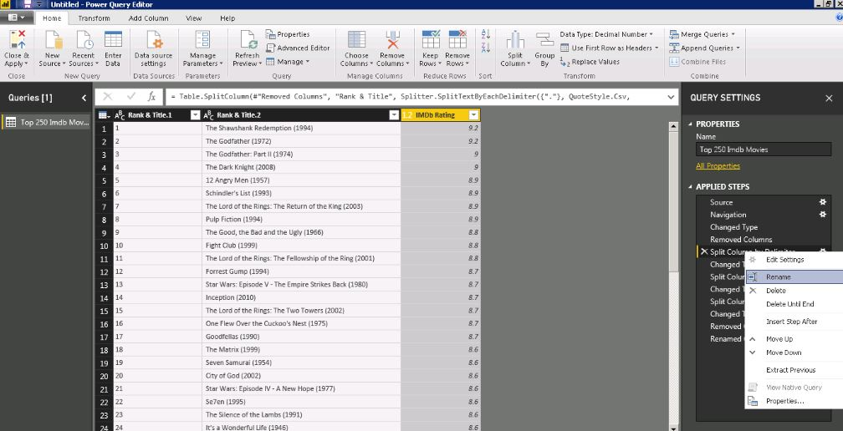

To save all the transformations applied, hit ‘**close and apply’**.

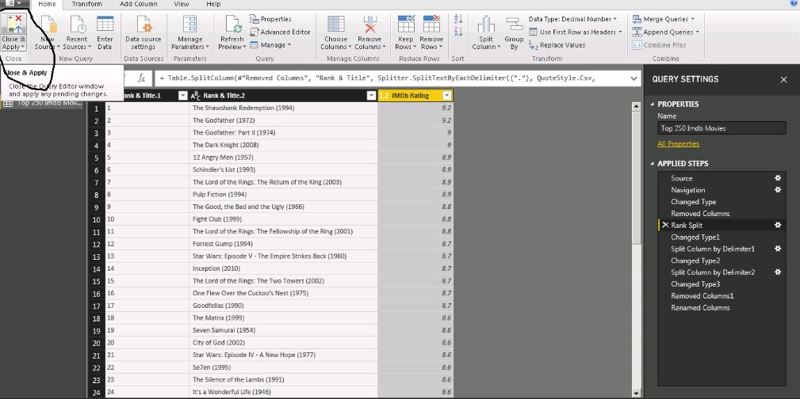

# 4. Data Visualization

1. From the Visualizations pane, select **Table**.

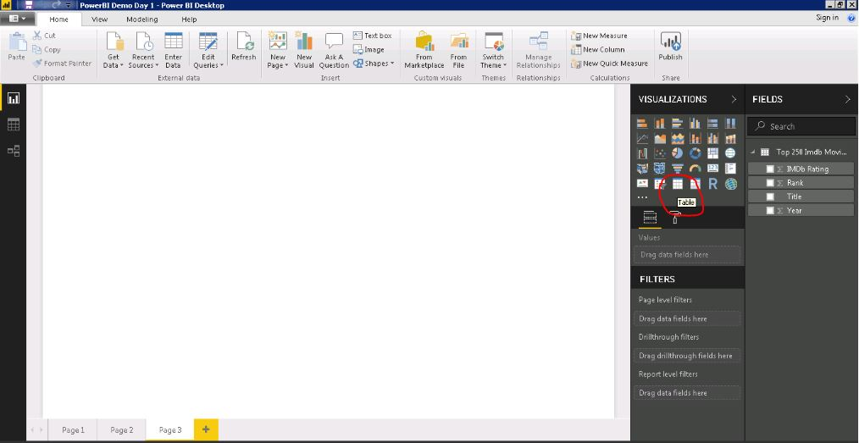

1. Choose the fields to be added in the table. In our case, we take ‘**Ran**k’ and ‘**Title**’ and ‘**IMDb Rating’**. To select the fields, check the boxes right next to the field name as shown in the image below.

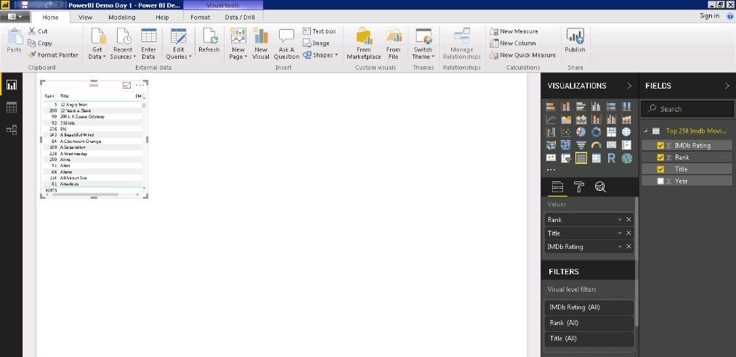

1. To format the size of the data in the table, click on the **Format** tab in the Visualization Pane.

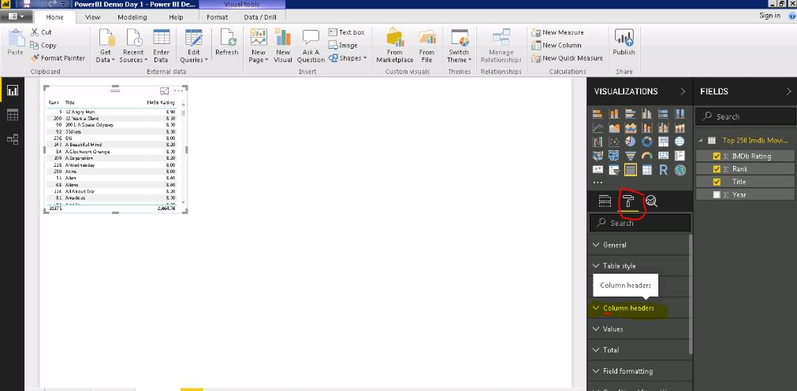

1. Click **column header** and change the font size. Similarly, click **‘Values’** and change its font size.

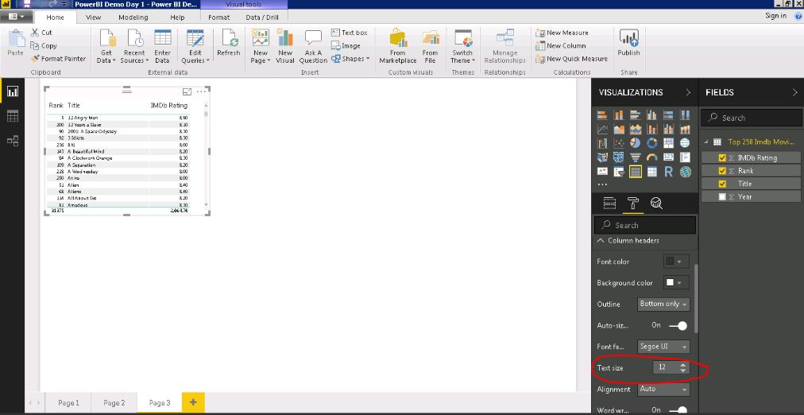

1. In the **Format** Tab, click ‘**Total**’ and slide the toggle to off. This would make the data in Table readable.

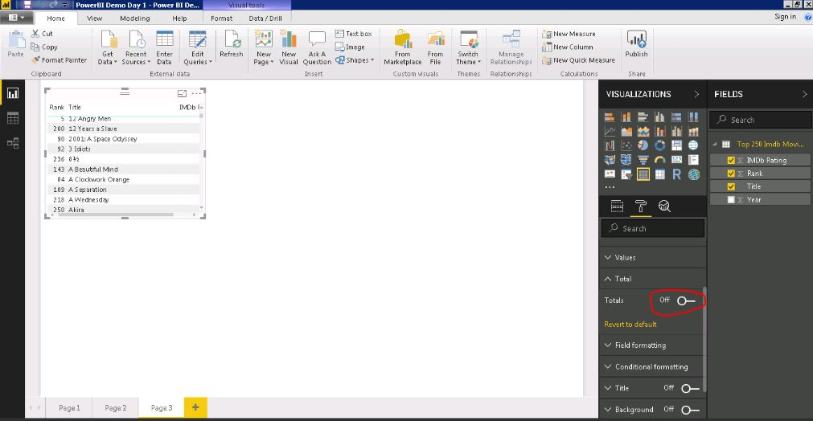

You can resize the visualization part by dragging from the sides.

1. Now click anywhere on the page to unselect your current visualization. To choose another visualization, Select from the visualization Pane. This time we choose a **slicer**.

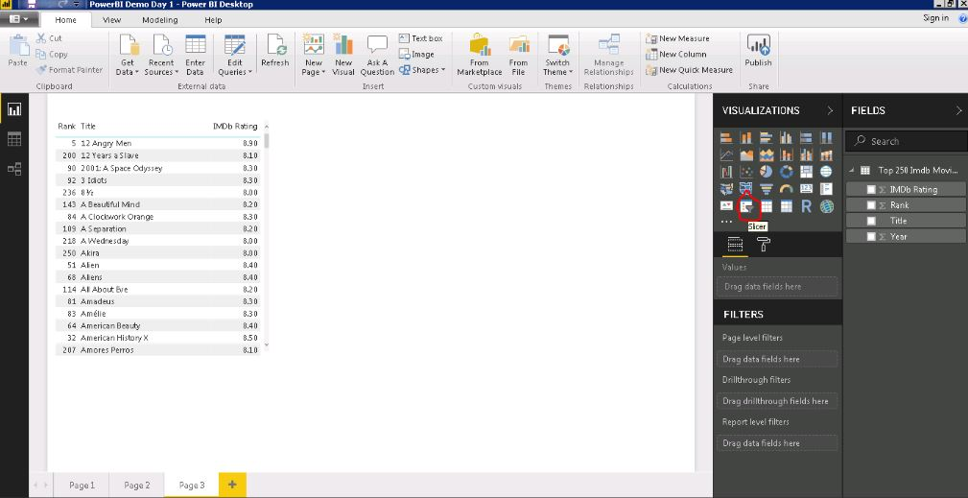

1. Check the field ‘**Year**’ to put in the **Slicer.**

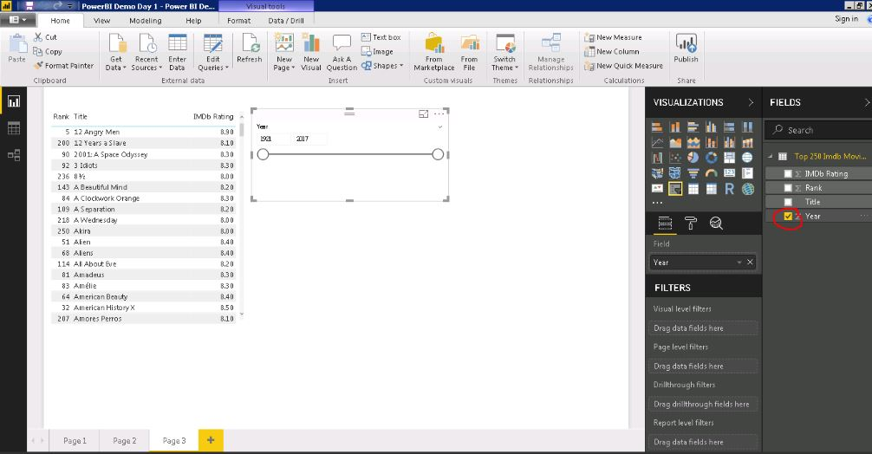

1. Next, we choose a card to show the number of movies. To perform this, first select the **card** visualization from the pane.

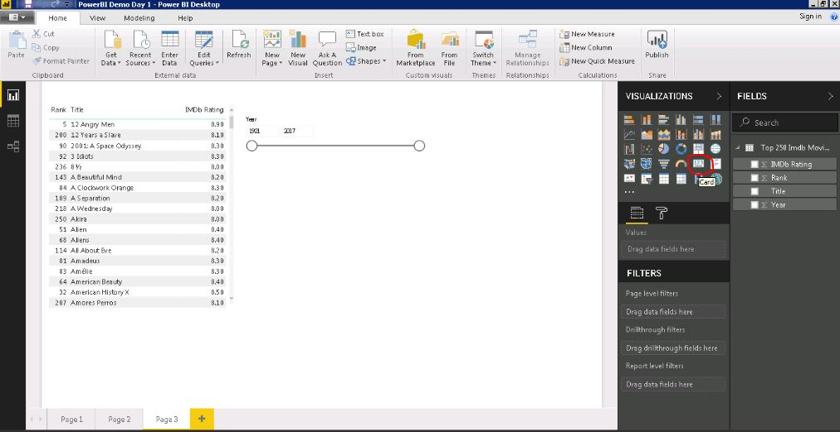

1. Check **Title** field to be put in the card. By default, it would show the Title only. To get the count of the movies we need to follow one additional step.

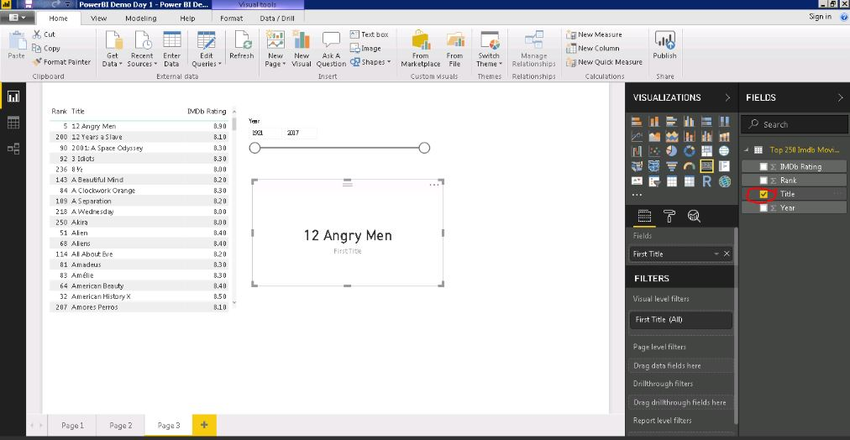

1. In the **Fields Pane**, right click on the field i.e. **Title** and select **Count Distinct** as the option. This would show all the distinct movie names present in our data.

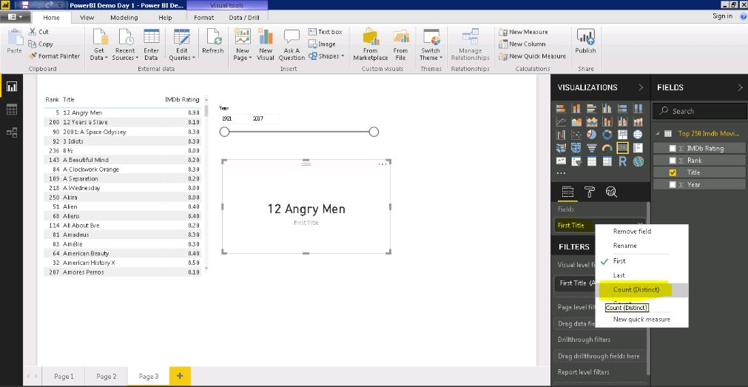

1. Lastly, we add a text box on the page to write some static information. Here, we write, ‘**My First Power BI attempt**’.

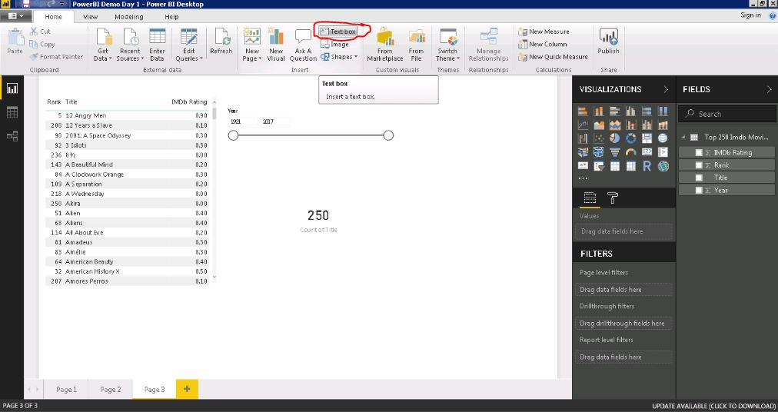

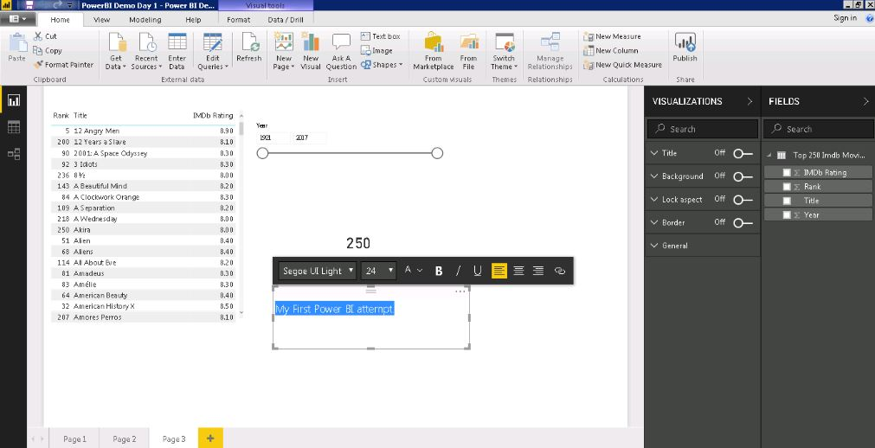

1. To Save your work, Click ‘**Save As**’ option from the ‘**File**’ menu, type File_name and click **OK**. Your file will be saved with an extension ‘.**pbix**’.

**Summary**  
  
In this exercise,

1. We have learnt importing data from Web Url.
2. Basic Transformation like, removing columns, renaming them, splitting columns based on delimiters.
3. Renaming the steps applied in Query Settings.
4. Create Visuals like Table, Slicer, Card and a text box to represent data in an appropriate way.